第十六章 无穷级数

知识点：

级数公式：
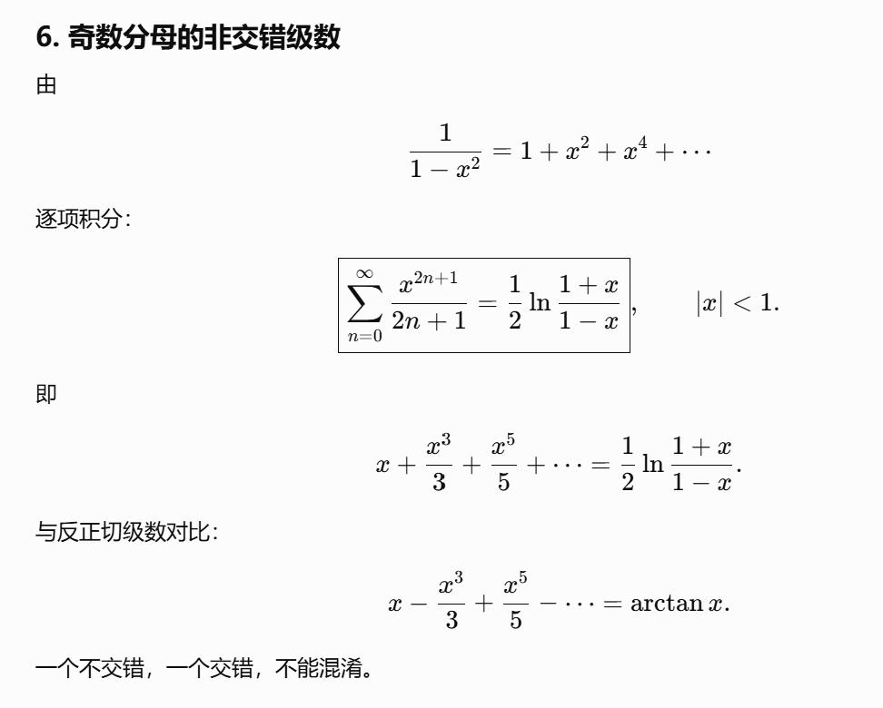
https://chatgpt.com/g/g-p-6a1d505226e08191a7f47eb8e9418ffe-gao-shu-ocr/c/6a61afba-3ba4-83ee-bf72-67c9eb30c1cc

反常积分：
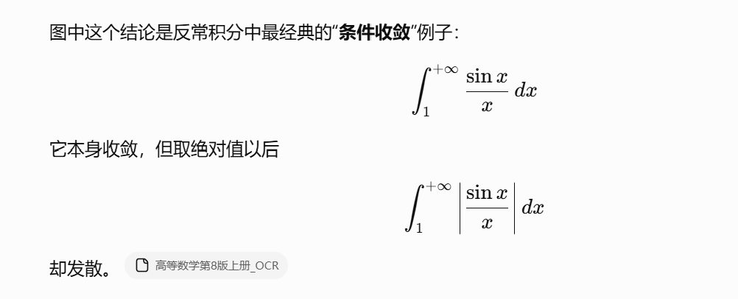
https://chatgpt.com/g/g-p-6a1d505226e08191a7f47eb8e9418ffe-gao-shu-ocr/c/6a5f7007-fa10-83ee-8993-61ad16330121

定理：

Stolze定理：
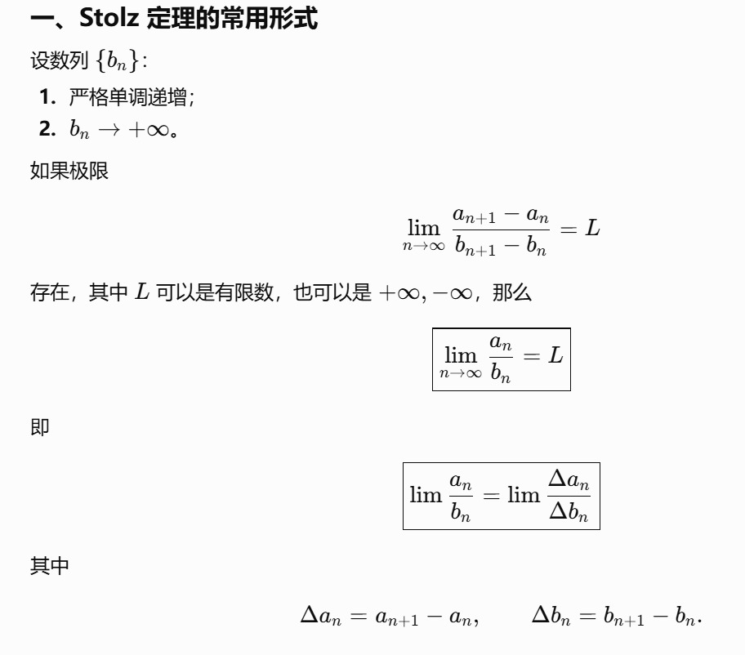
https://chatgpt.com/c/6a672d82-c370-83ee-a6a6-679df08757a5
https://chatgpt.com/c/6a6738bb-6a78-83e8-88ee-33d8e9ceab7b

总结：
https://chatgpt.com/g/g-p-6a1d505226e08191a7f47eb8e9418ffe-gao-shu-ocr/c/6a5ddb97-8490-83e8-be51-abf4504d3cf4

题：

题1：
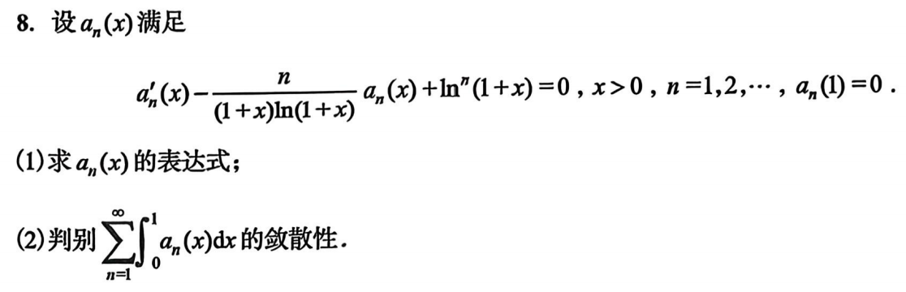
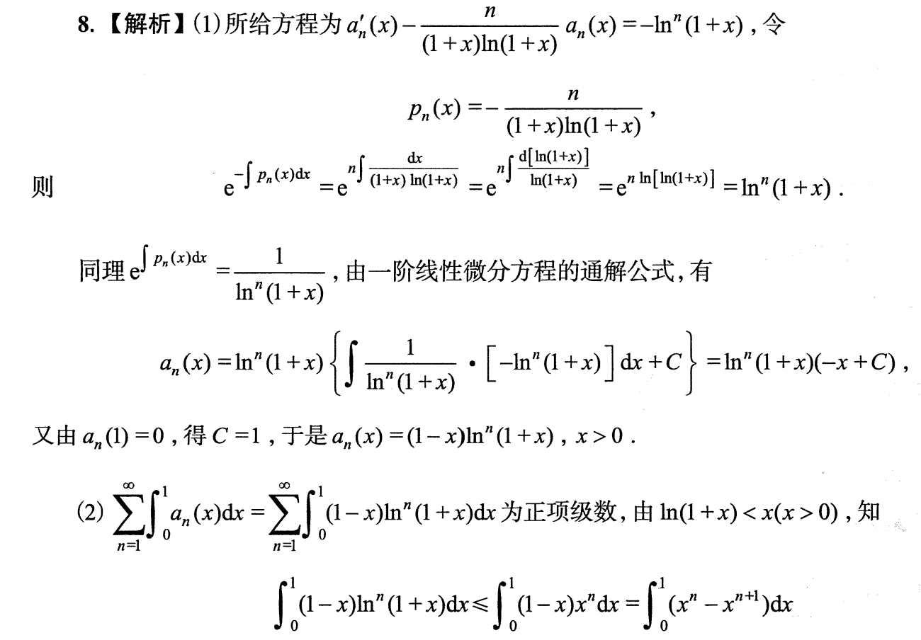
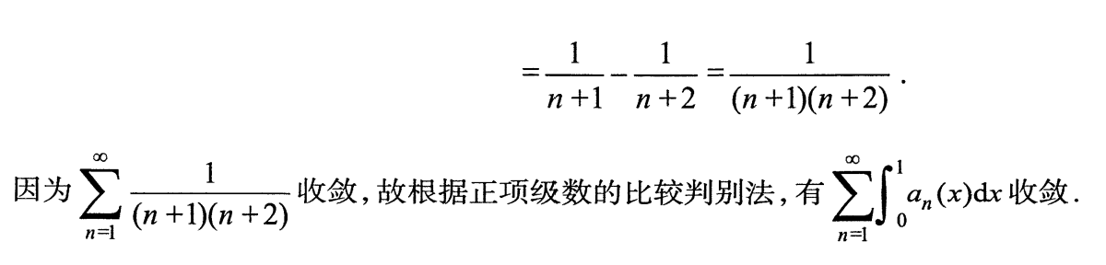

题2：
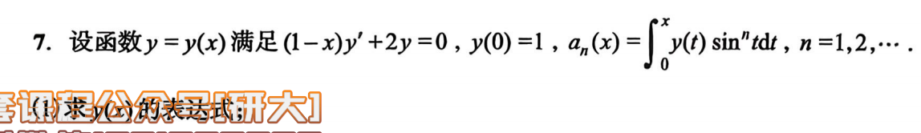

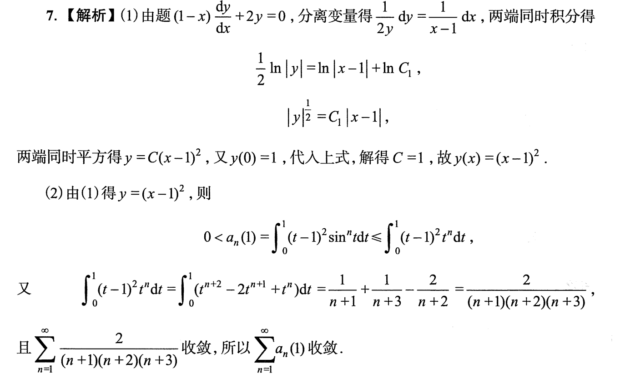

题3：
[图片下载失败]
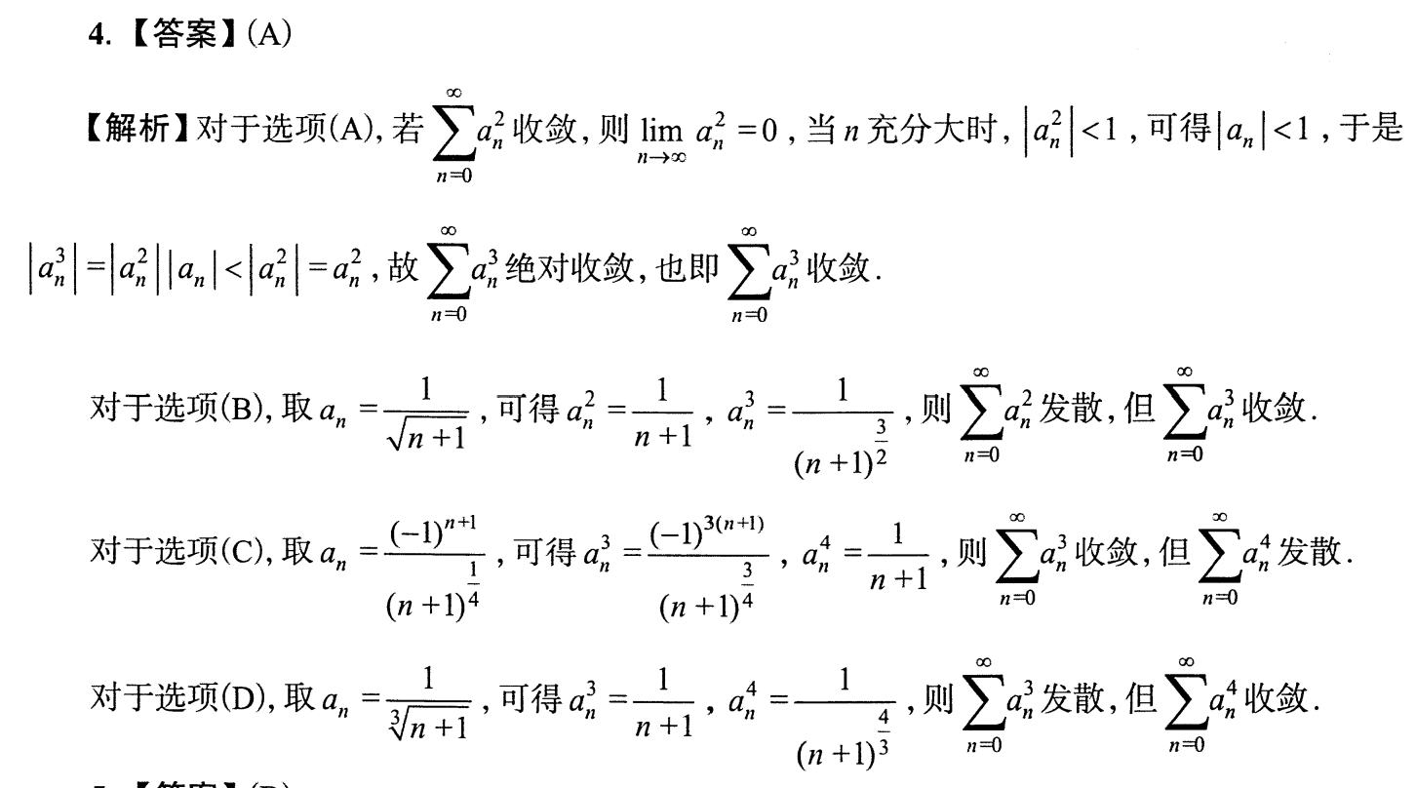
https://chatgpt.com/g/g-p-6a1d505226e08191a7f47eb8e9418ffe-gao-shu-ocr/c/6a5dfd63-fd74-83ee-bb3e-31d510df80c3

题4：
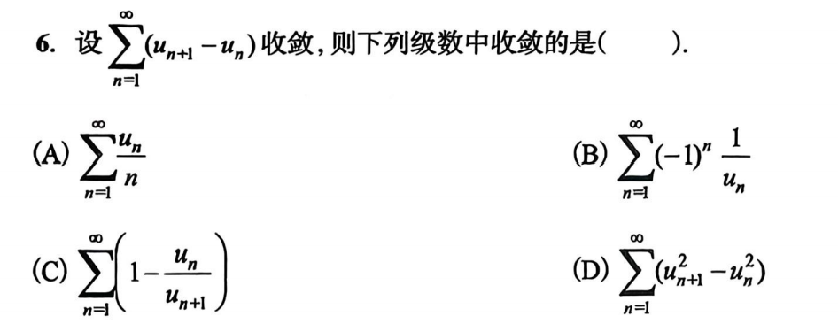
https://chatgpt.com/g/g-p-6a1d505226e08191a7f47eb8e9418ffe-gao-shu-ocr/c/6a5e0275-b2c4-83ee-a0a0-18a158add00a

题5(*):
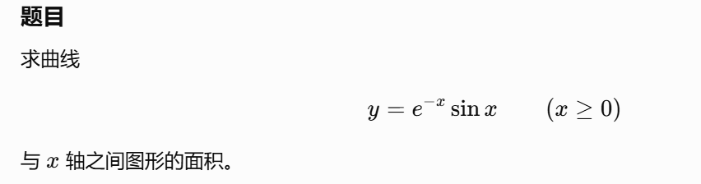
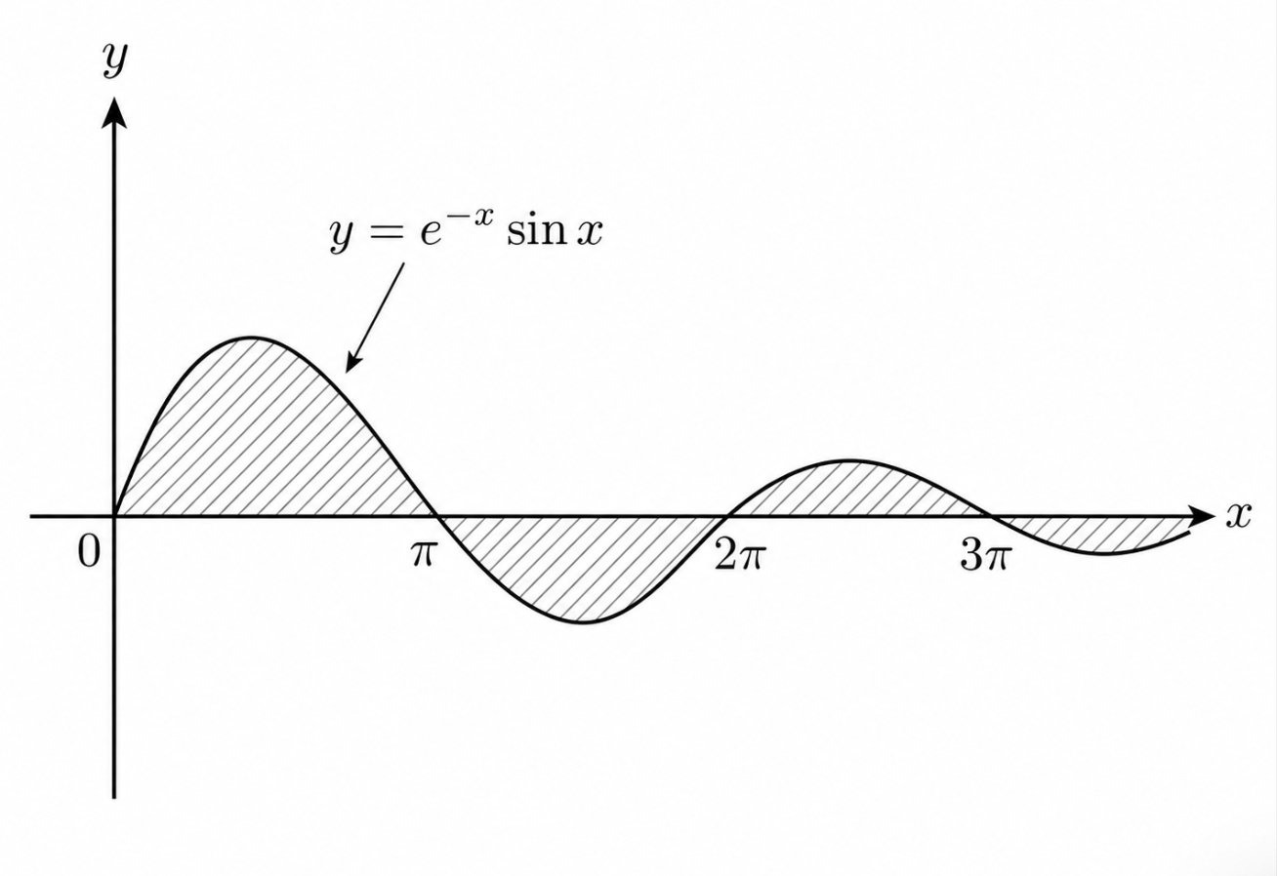
https://chatgpt.com/g/g-p-6a1d505226e08191a7f47eb8e9418ffe-gao-shu-ocr/c/6a609c03-67d8-83ee-a962-05b65e58faf8

题6：
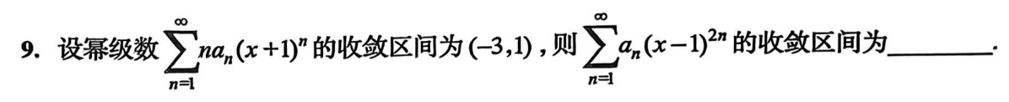
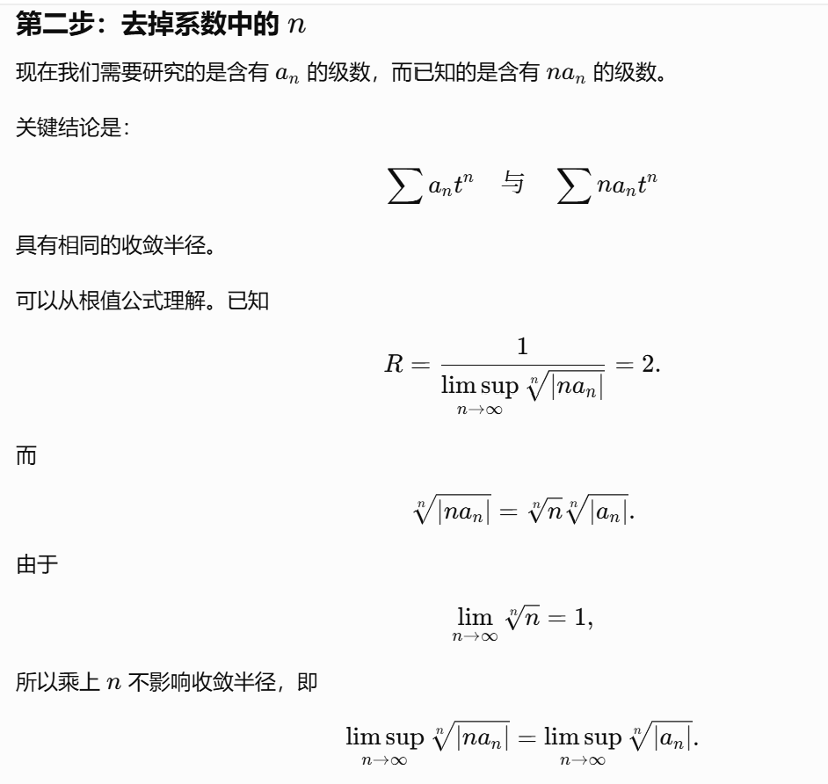
https://chatgpt.com/g/g-p-6a1d505226e08191a7f47eb8e9418ffe-gao-shu-ocr/c/6a6191d1-2ae8-83e8-9767-997b40dbe055

题7：
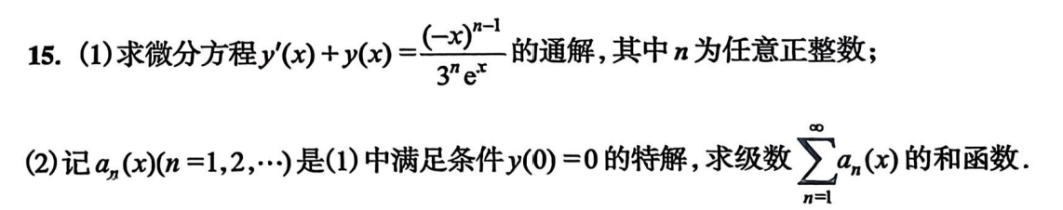
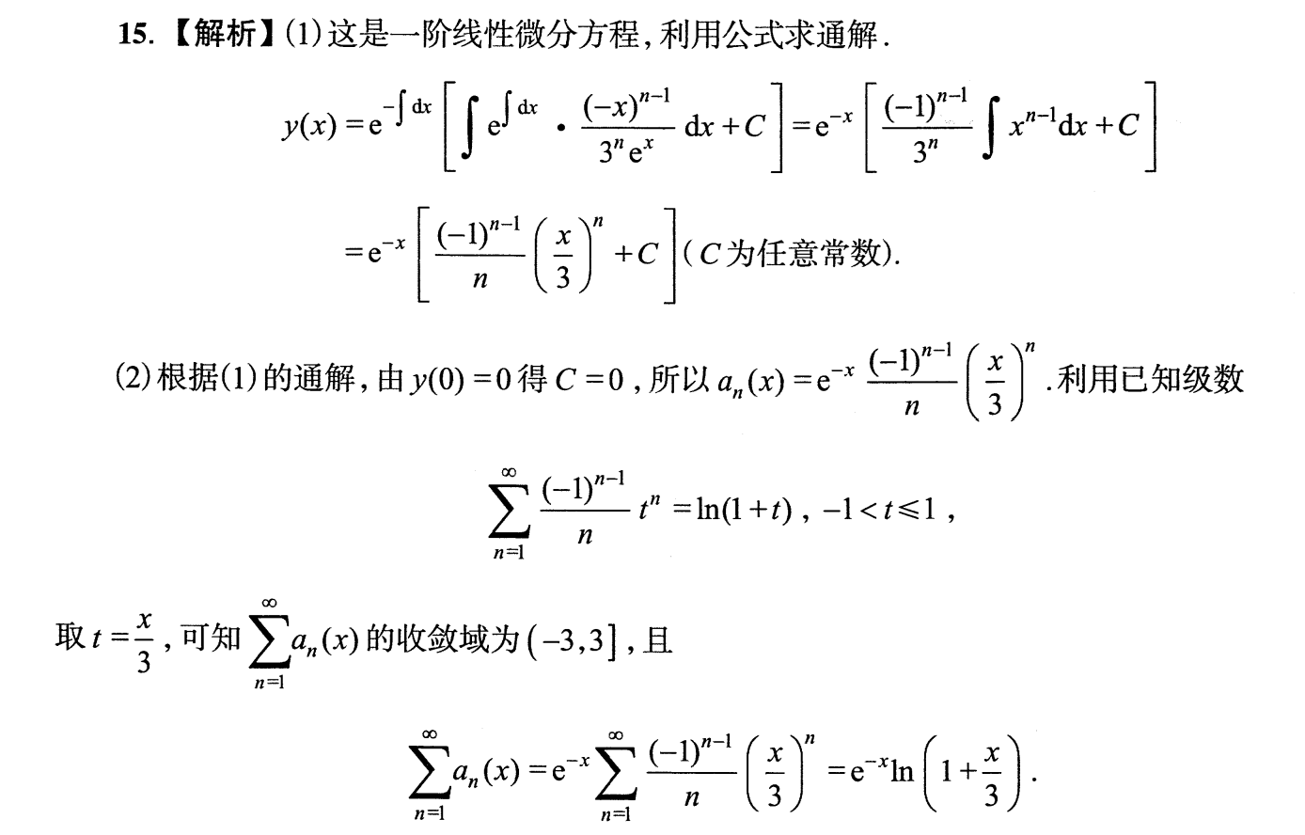

|（注：部分内容可能由 AI 生成）

